# Homework: Computer Systems and Software – Trello

Problems for homework for the ["Software Technologies" course @ Software University.](https://softuni.bg/trainings/4086/software-technologies-may-2023)  
Submit this document as your homework.

## Travel Bucket List

**1.** Create a **new board named "Travel Bucket List"**. Do not use templates.

**2.** Add **a list for each continent** that you want to visit. /**Example:** Europe, Australia/

**3.** **Add three cards for each continent** **list. Each card** representing a **country or location** you want to visit. /**Example:** List Europe – cards – Paris, Italy, Fishing village in Portugal/.

**4.** Use **the label feature** to categorize the destinations by type (beach, adventure, culture, hobby etc.).

**5.** Use **the description feature** to add any must-see attractions and or activities.

6. Add **due dates** for each destination you want to visit in the next five years.

7. Delete the example photo, take a **screenshot of your board** and add it instead.

**Example:**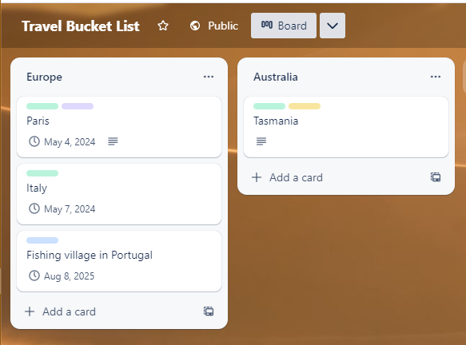

**8.** Delete the example photo, take a screenshot of **one of your cards,** and add it instead.

Example:  
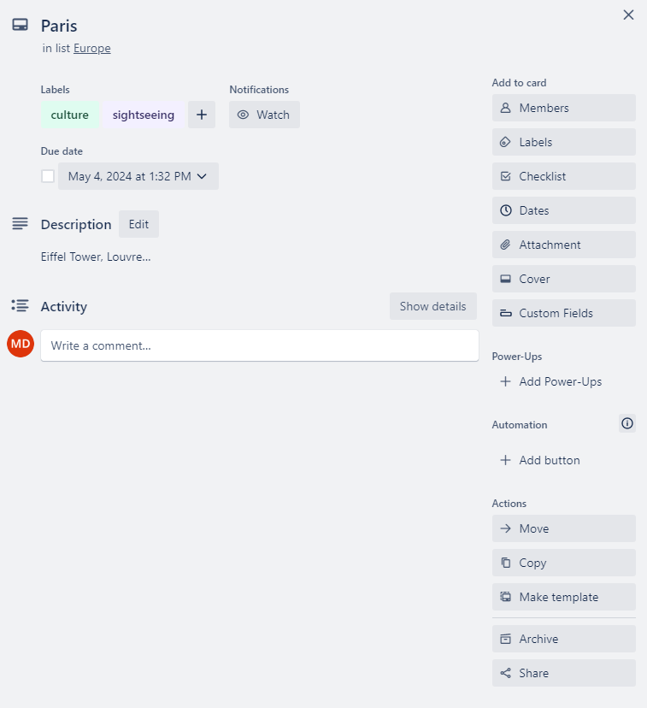

## Manage your Daily Tasks

**1.** Create a new board named "Daily To-Do List"

**2.** Add a list for each category of tasks (work, personal, school, etc.)

**3.** Add a "Today" list for your daily tasks

**4.** Add cards to each list with the tasks you need to complete

**5.** Use the label feature to categorize the tasks by priority (high, medium, low)

**6.** Use the due date feature to set deadlines for each task

**7.** Move tasks from the category lists to the "Today" list to focus on what needs to be done

**8.** Use Trello's mobile app to access your to-do list on the go and check off tasks as you complete them

**9.** Take a screenshot of your board with the lists that you created and add it here.

**10.** Take a screenshot of one of your cards that you already completed and add it here.